**Chat Application Project With K8s Deployment**

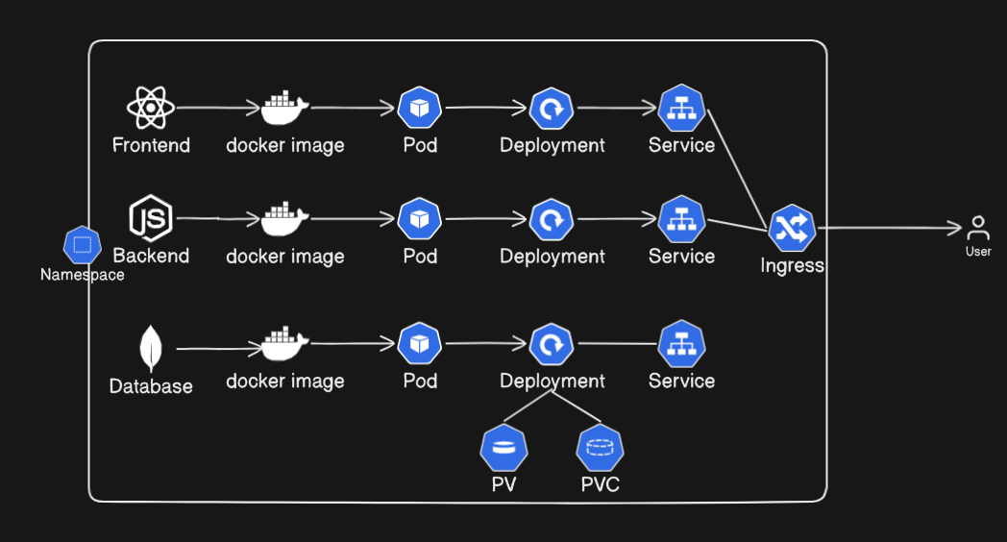

**1)Project Clone**

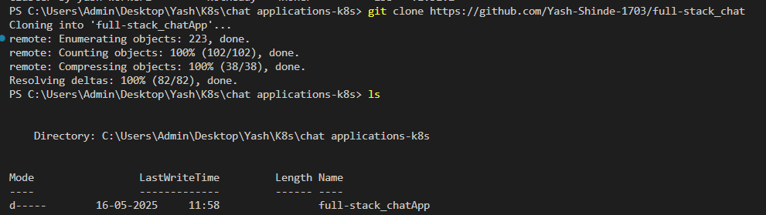

2)Image Build for backend

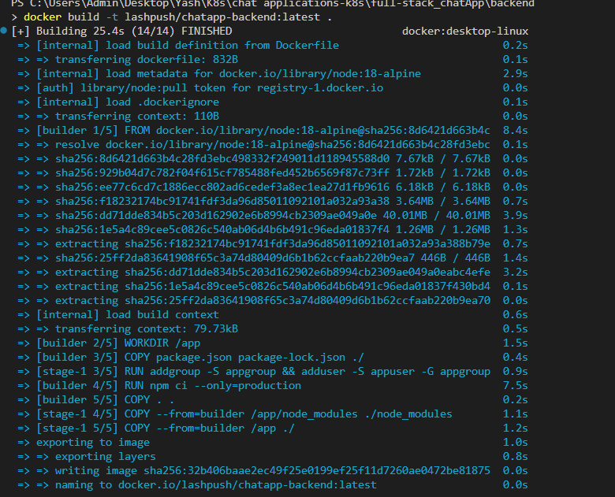

3)Image Pushed to Docker hub with login

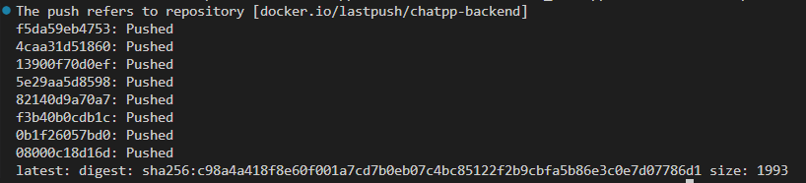

4)Image Build for fontend

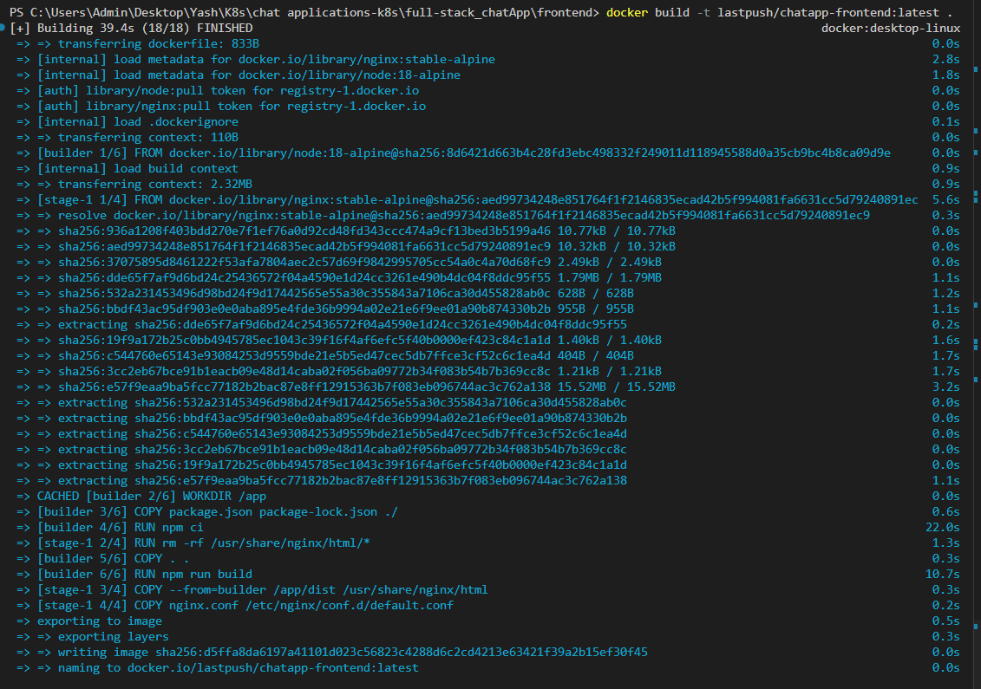

5)Image Pushed to Docker hub with login

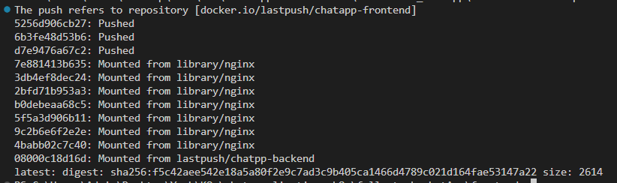

6)Namepaces file for project

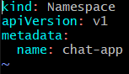

7)write Deployment file for backend

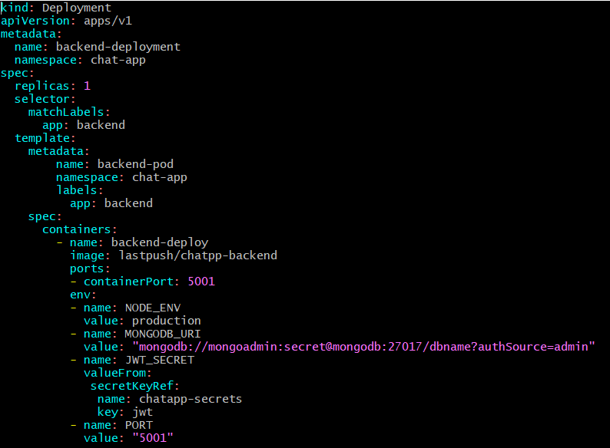

8) write Deployment file for database

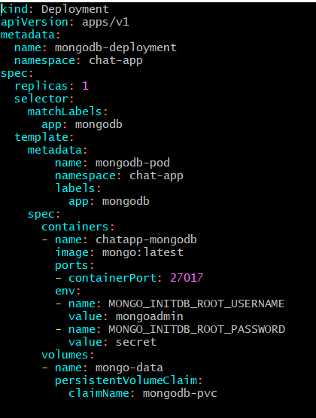

9) write Deployment file for frontend

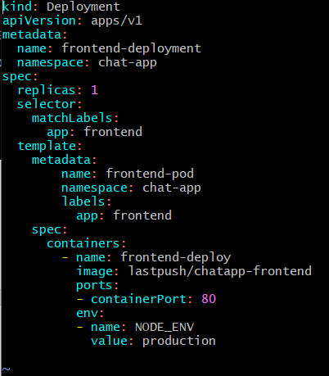

10) Yaml file for other service ,Peristent volume ,PVC and run it all and check below sevices

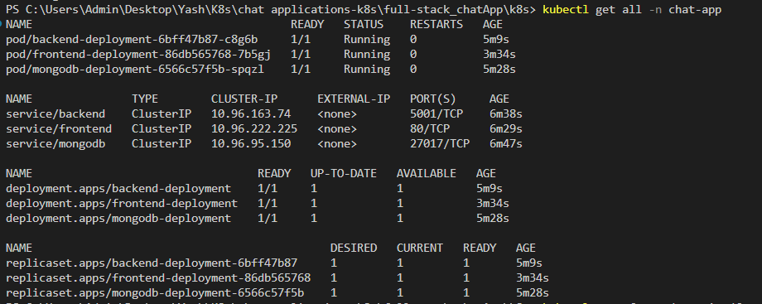

11)Port-forward on mentioned port number using same service runing

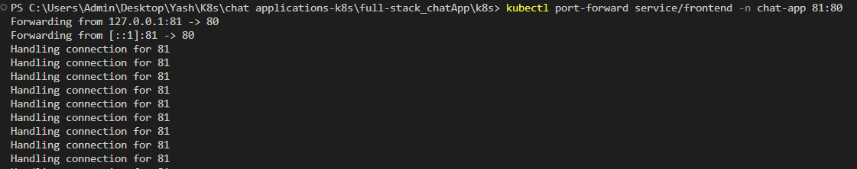



12)Check out the result

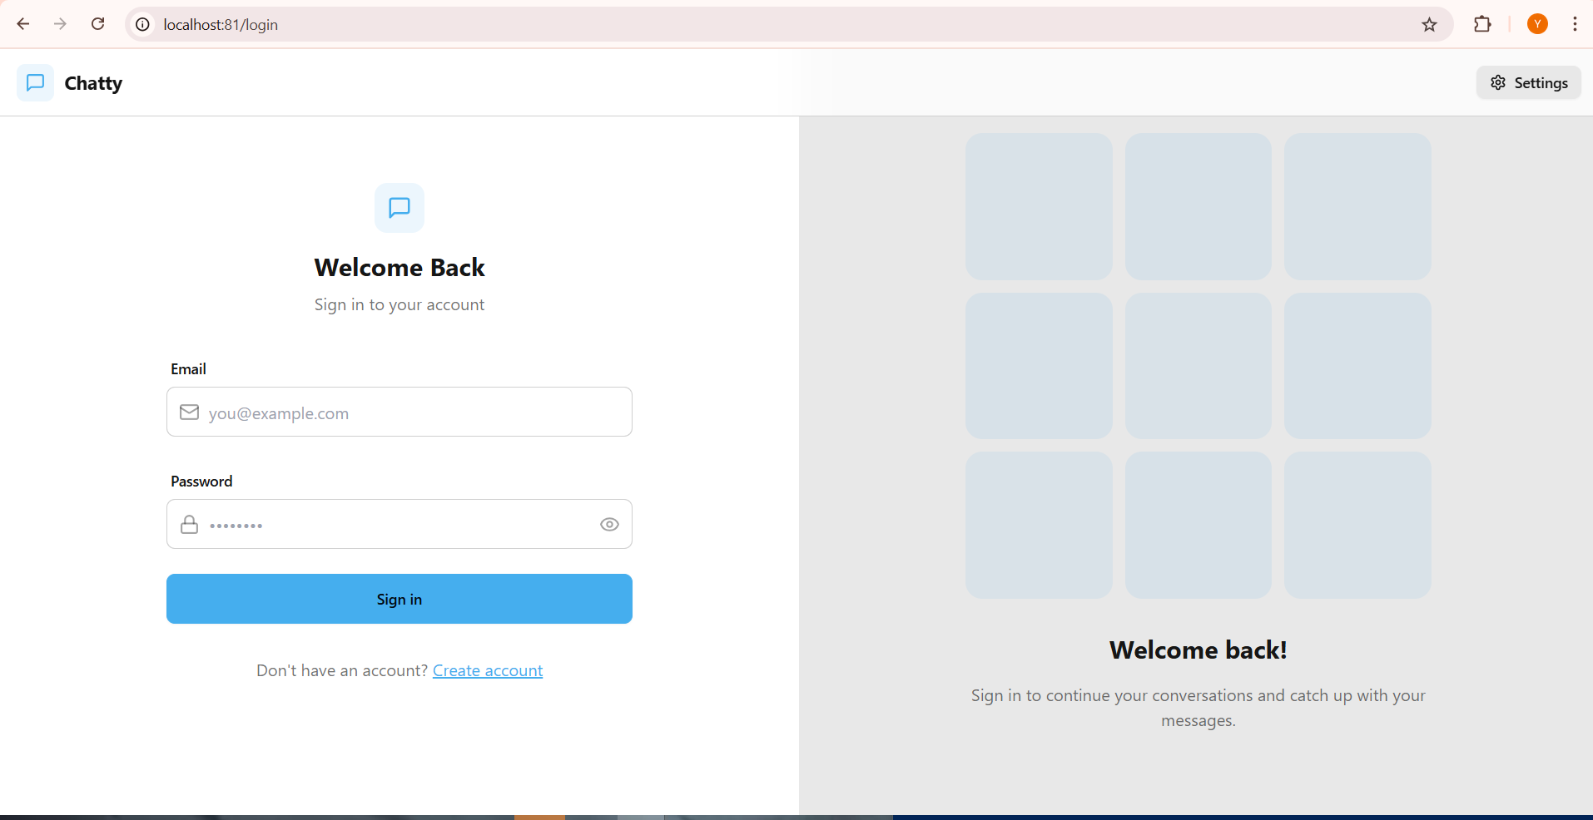

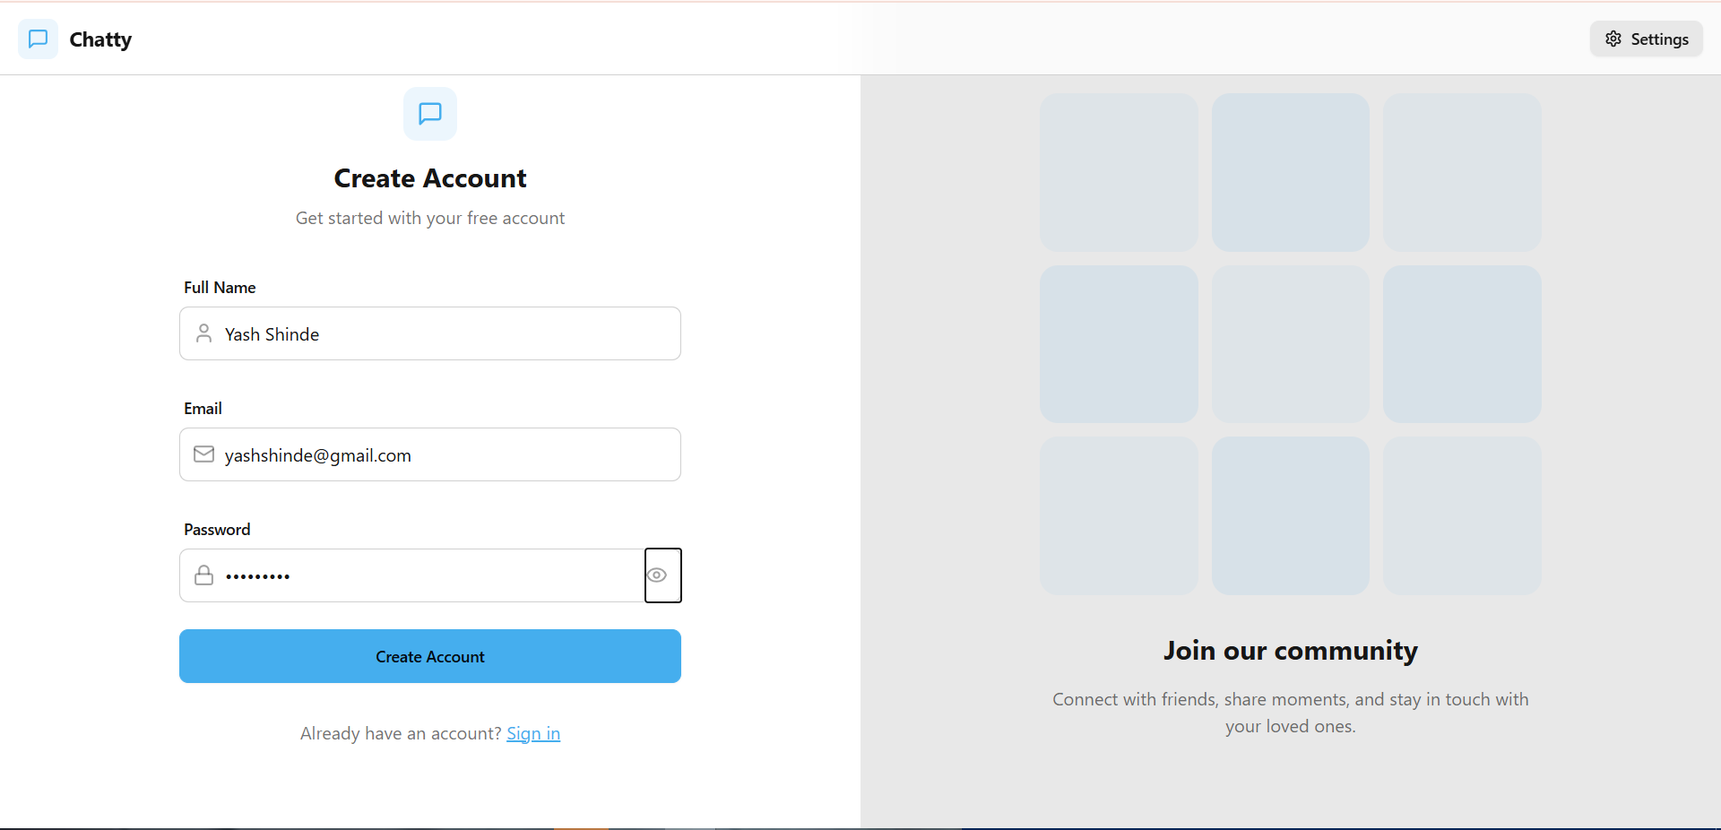

Realtime chat with two different accounts with faster reflections

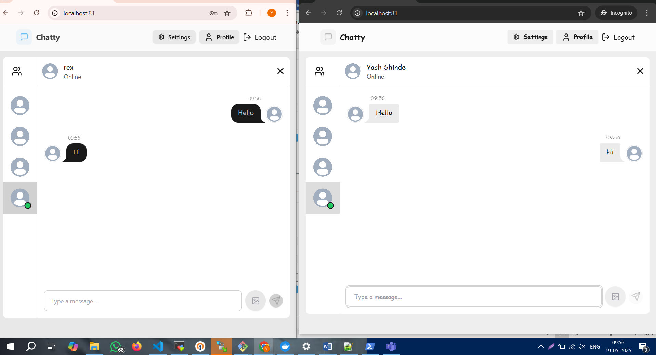

**Voting App with K8s,Argocd**

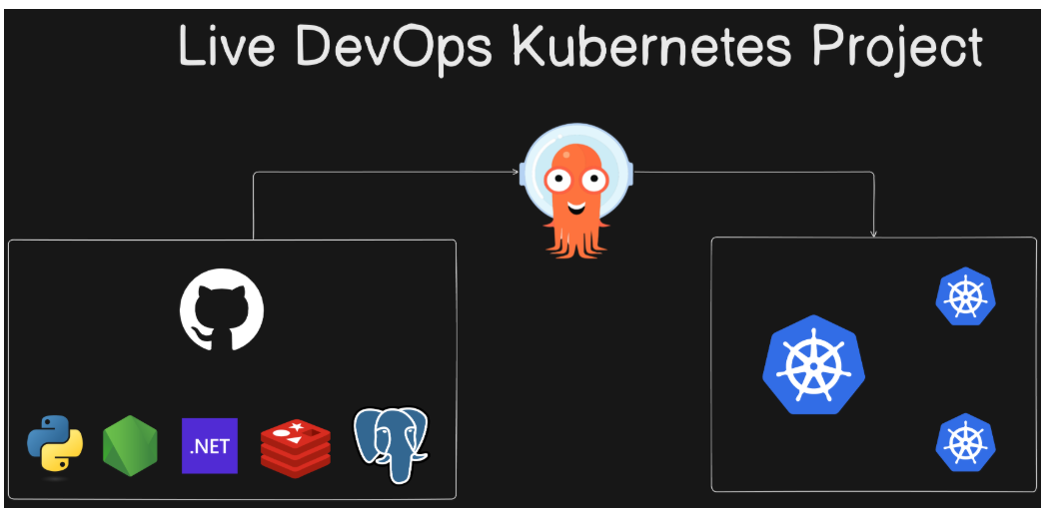

Project cloned

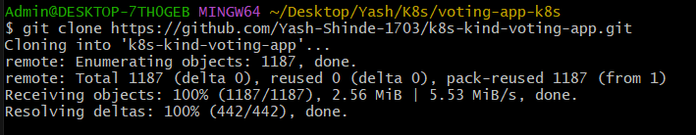

Setting up and installing argocd

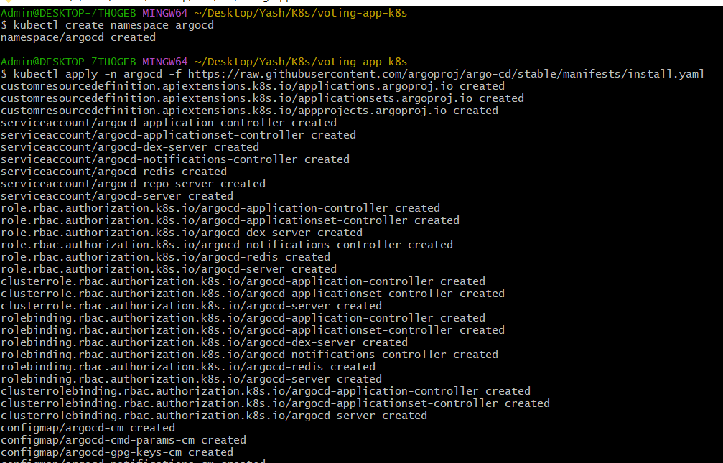Services Running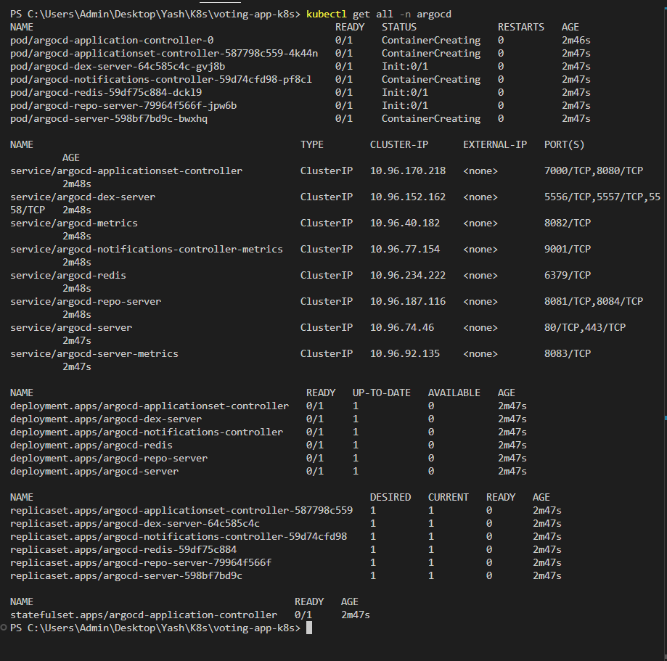

Port-forwarding

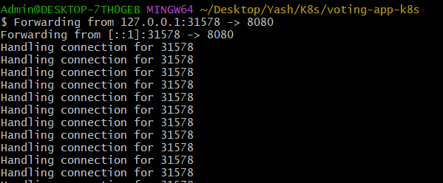

Check out the login page

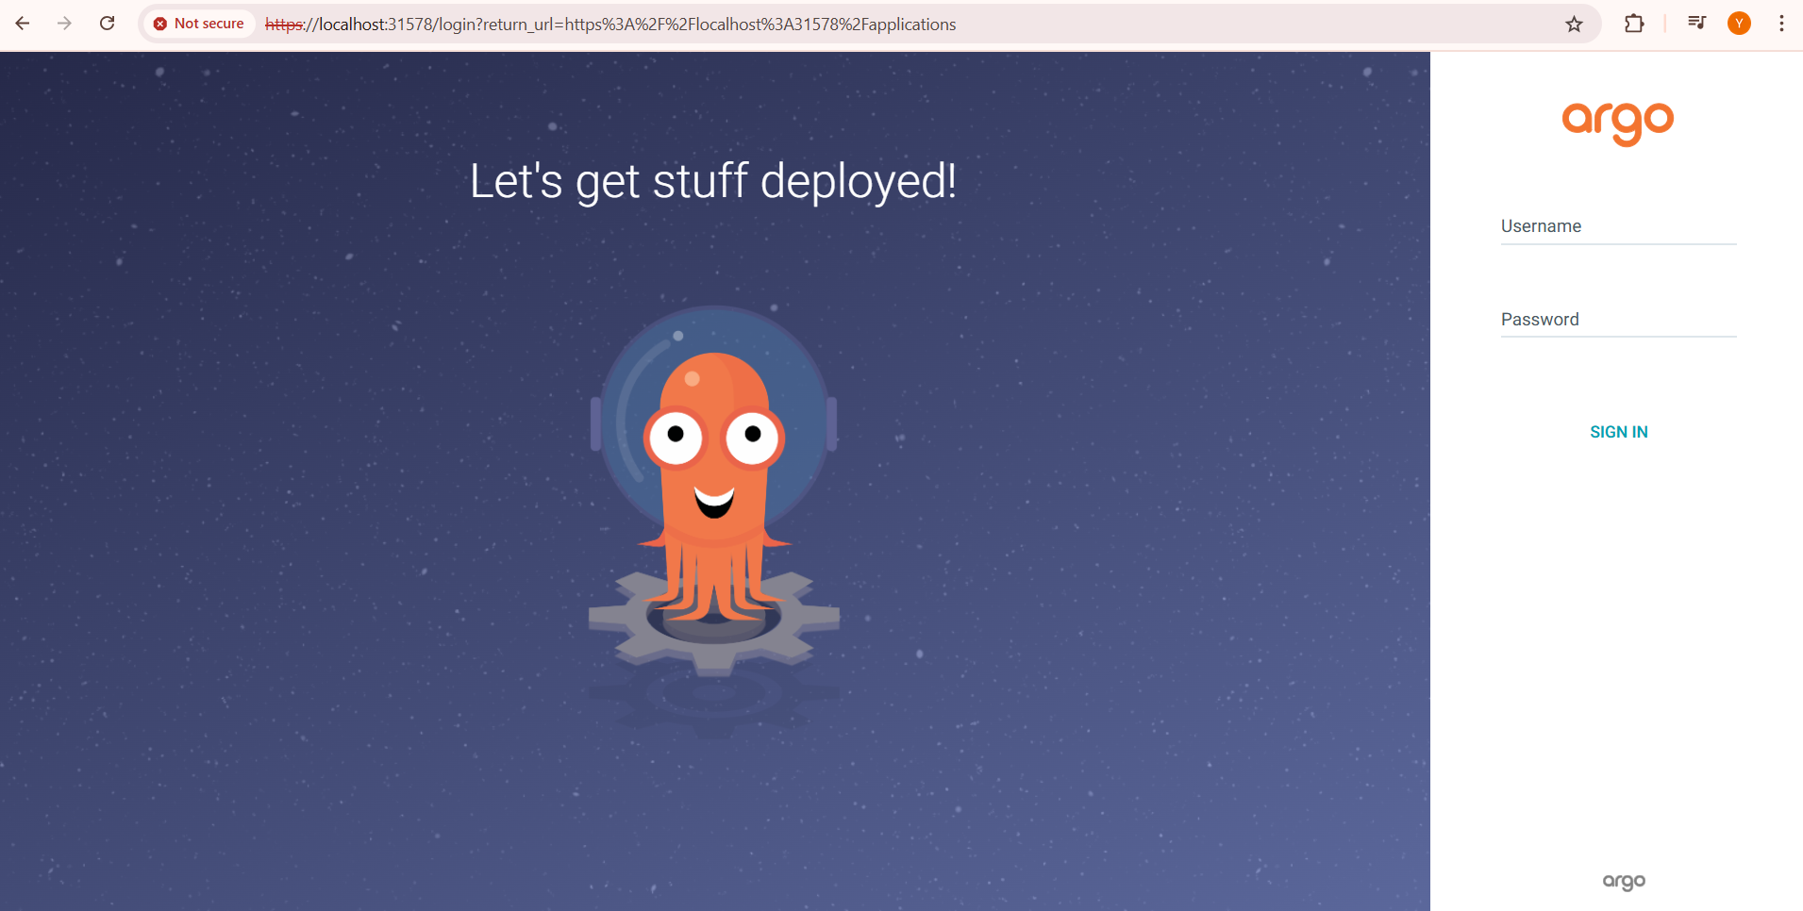

Get password for login with below command



Overview of login

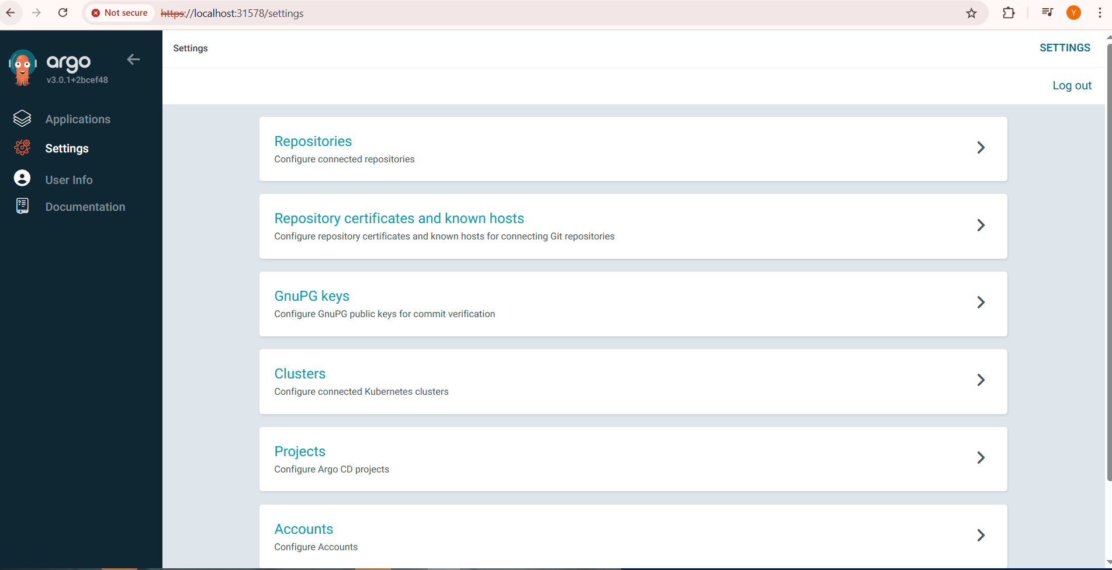

Creating applications

Fill the yaml file information for application

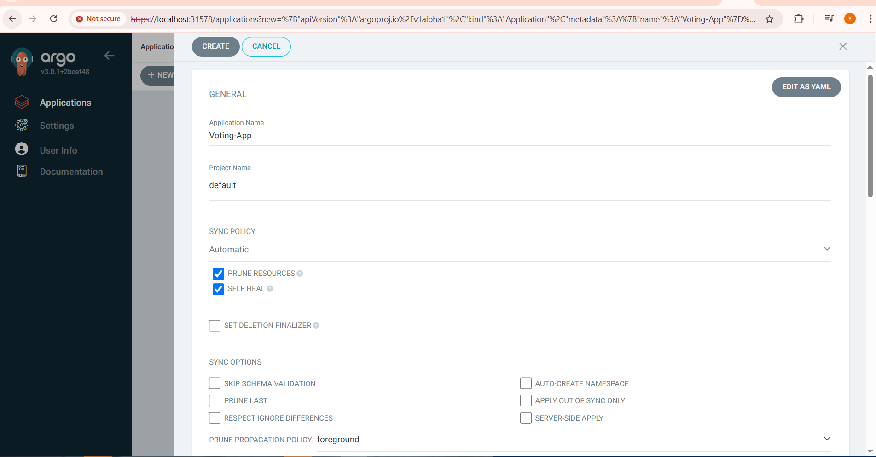

Adding github repo details

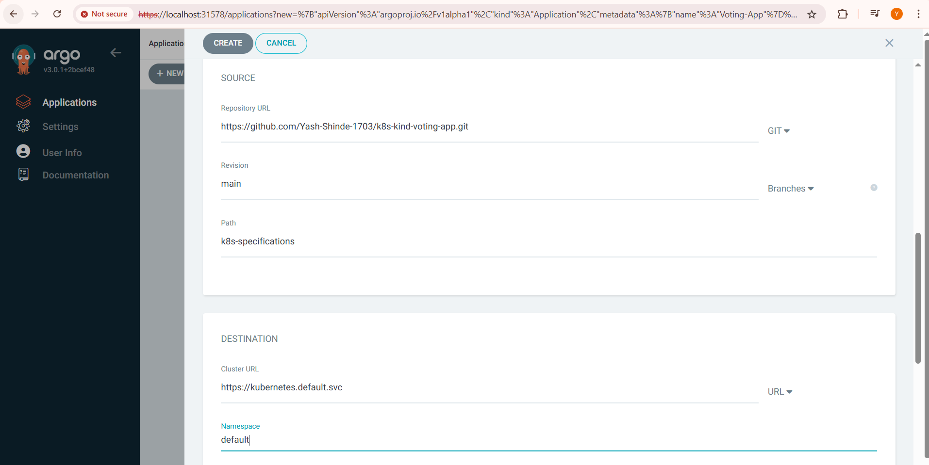

Wait till its sync

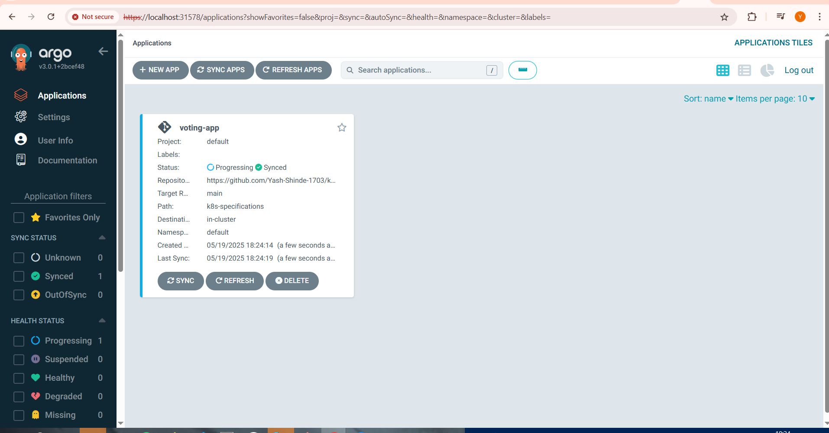

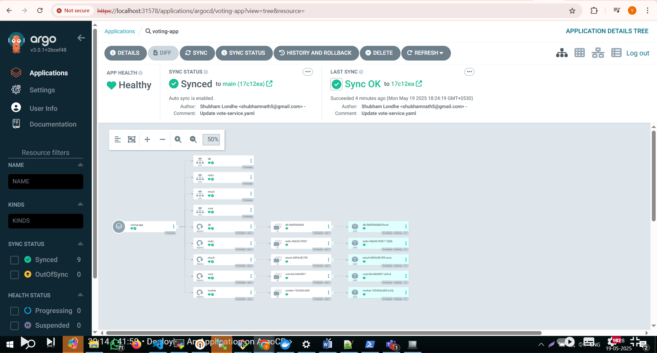

After sync check the status

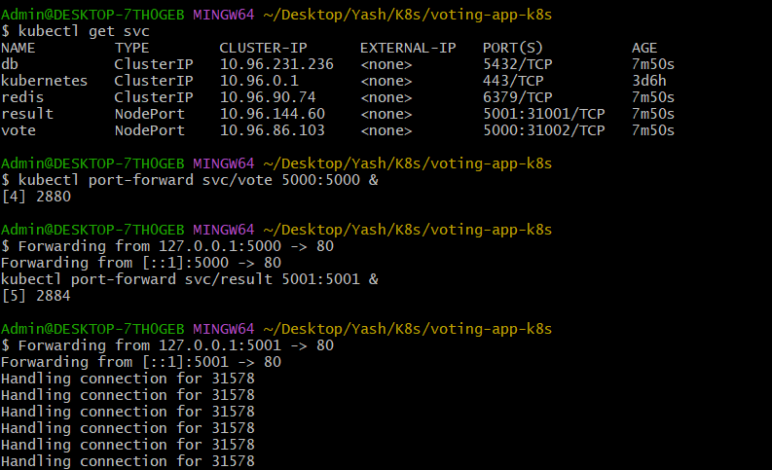

Results

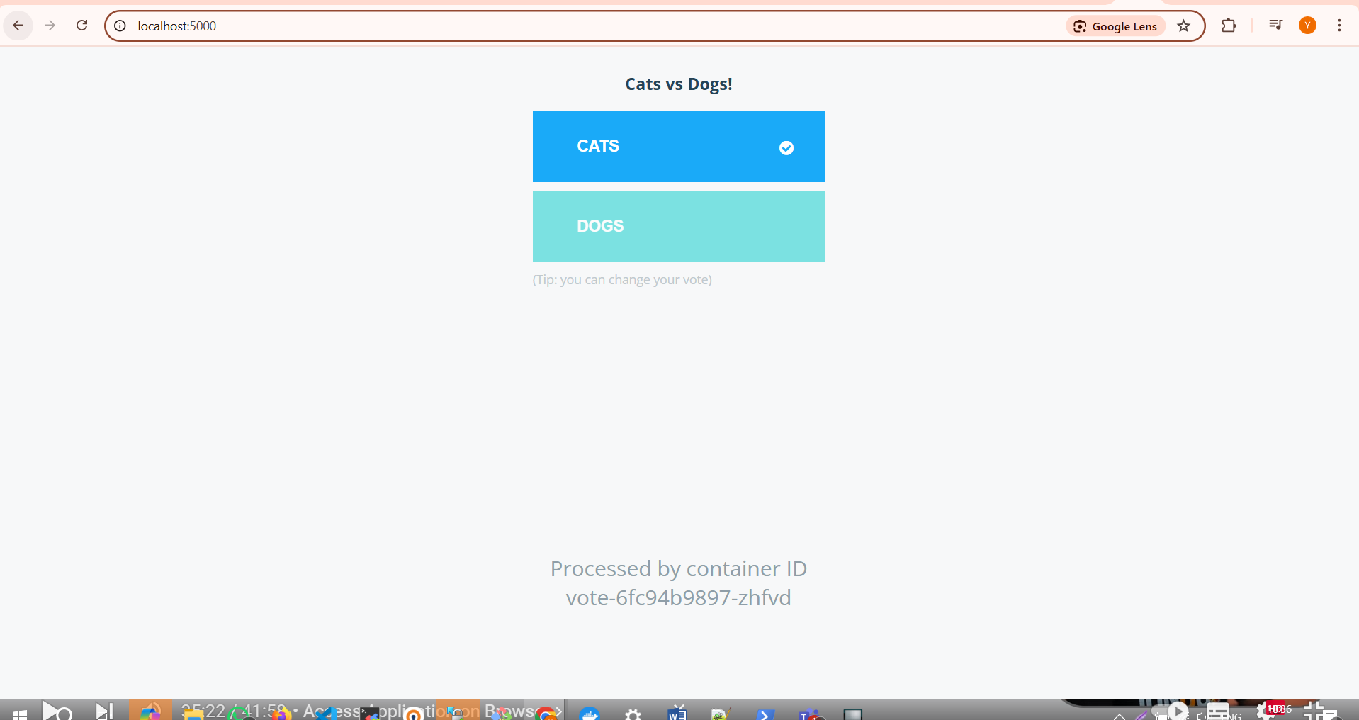

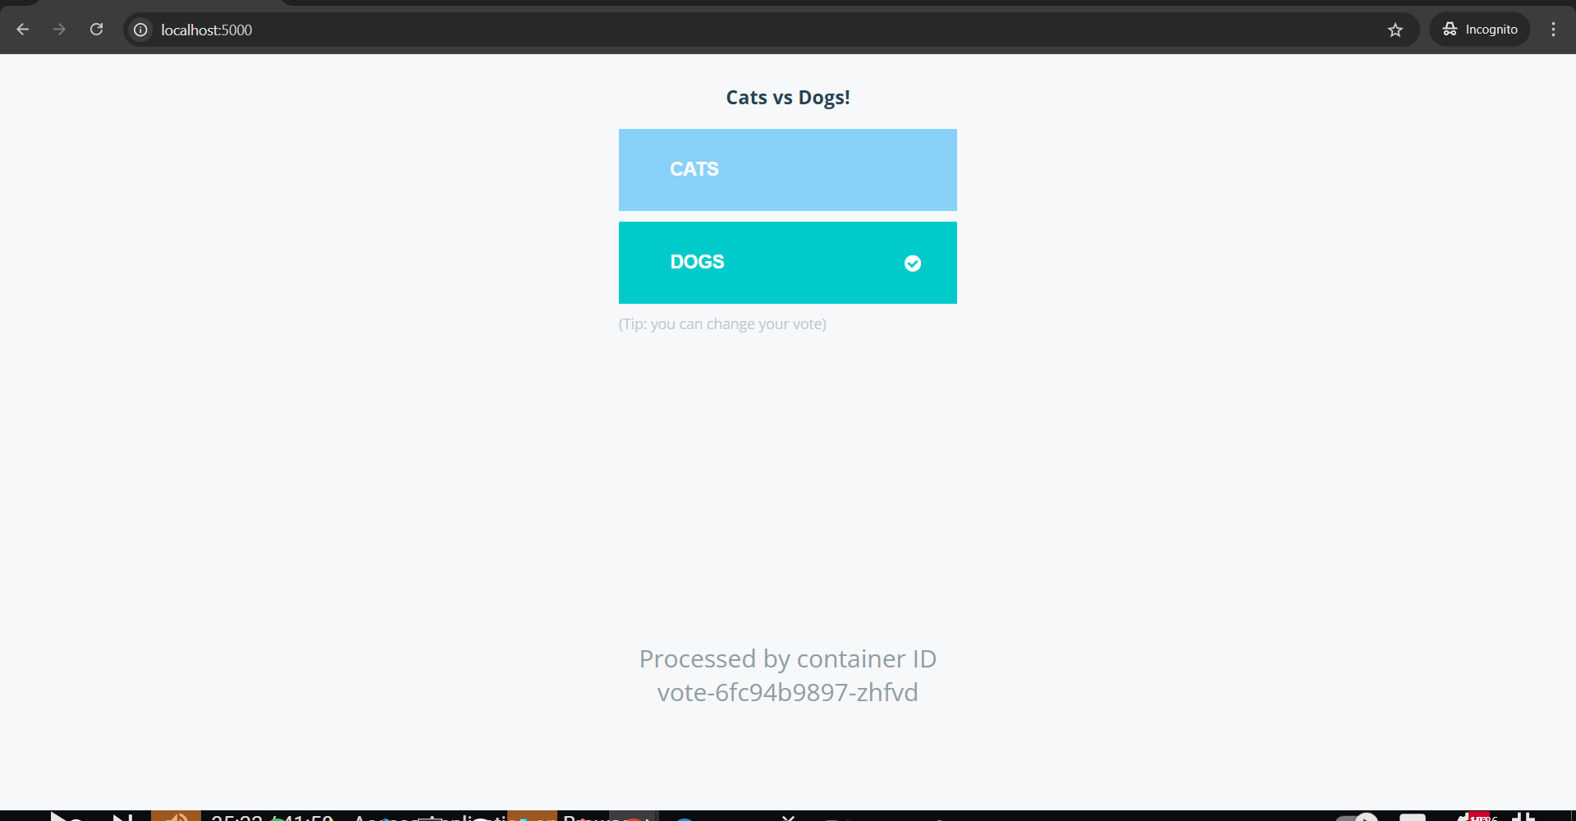

**Kubernets Monitoring using Promethus and Grafana with Helm chart**

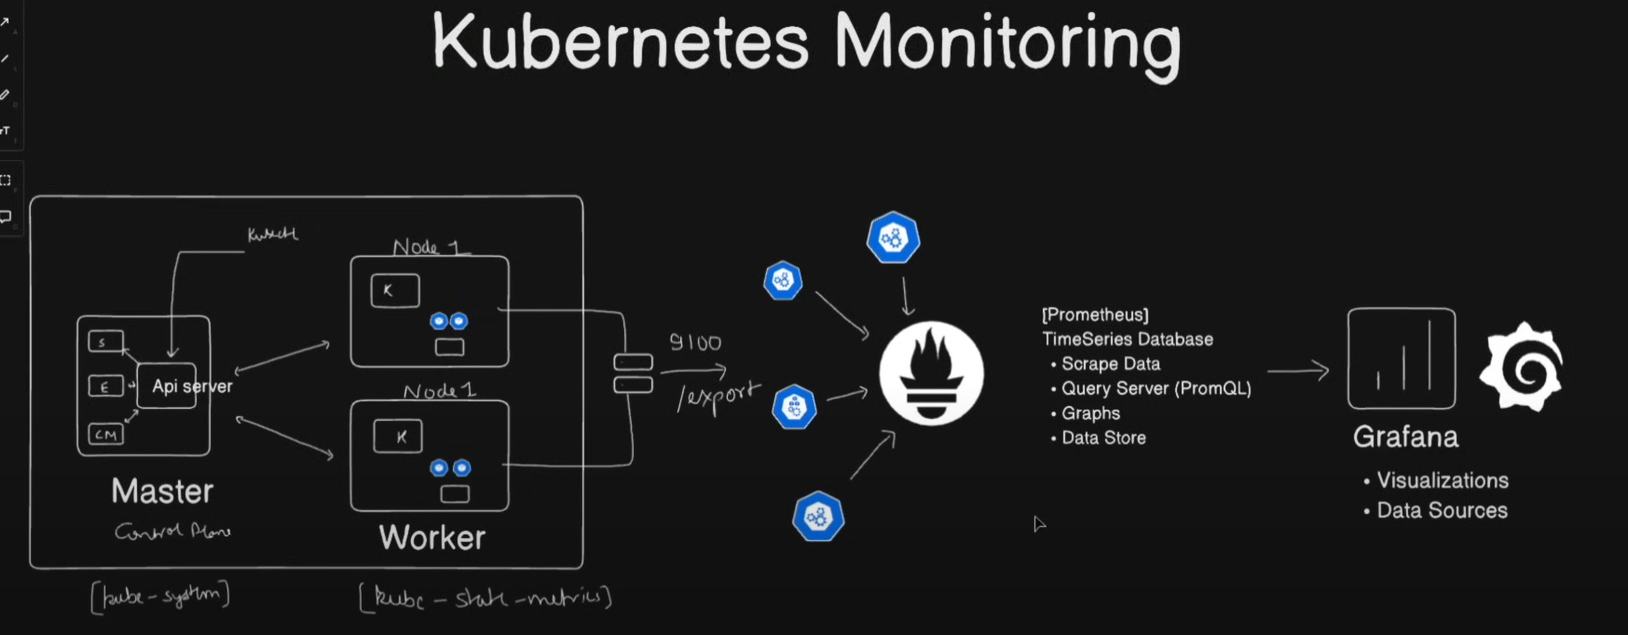

Installing promethus and grafana using helm

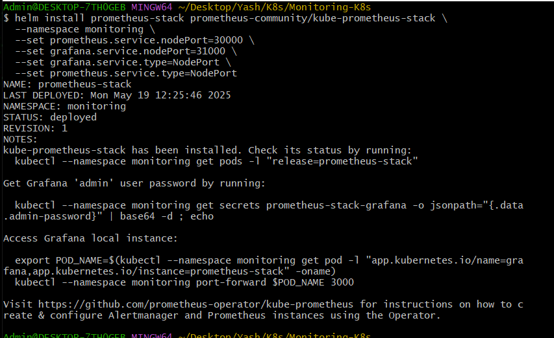

Check all the running servie

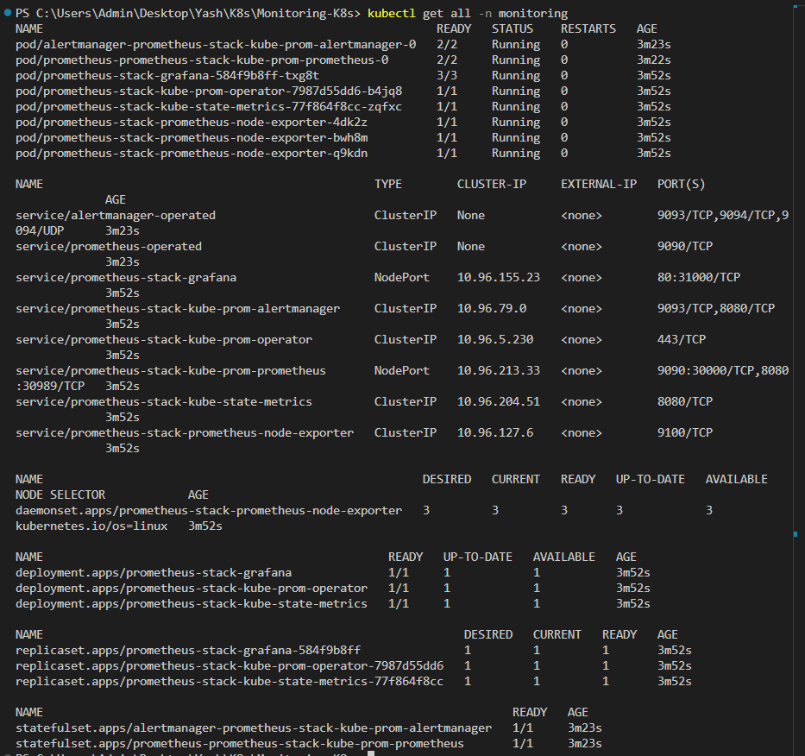

Port-forwarding for prometheus

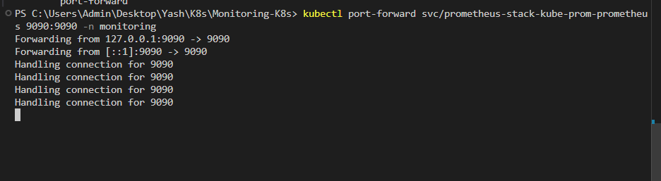

Check out on the browser

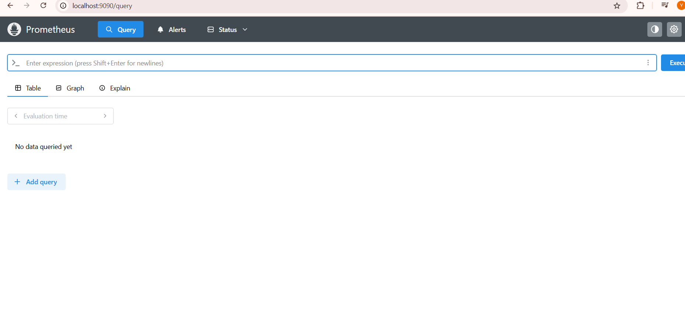

Port-forward for the grafana

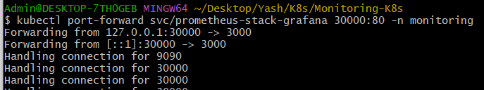

Check out on the browser on the mention port number

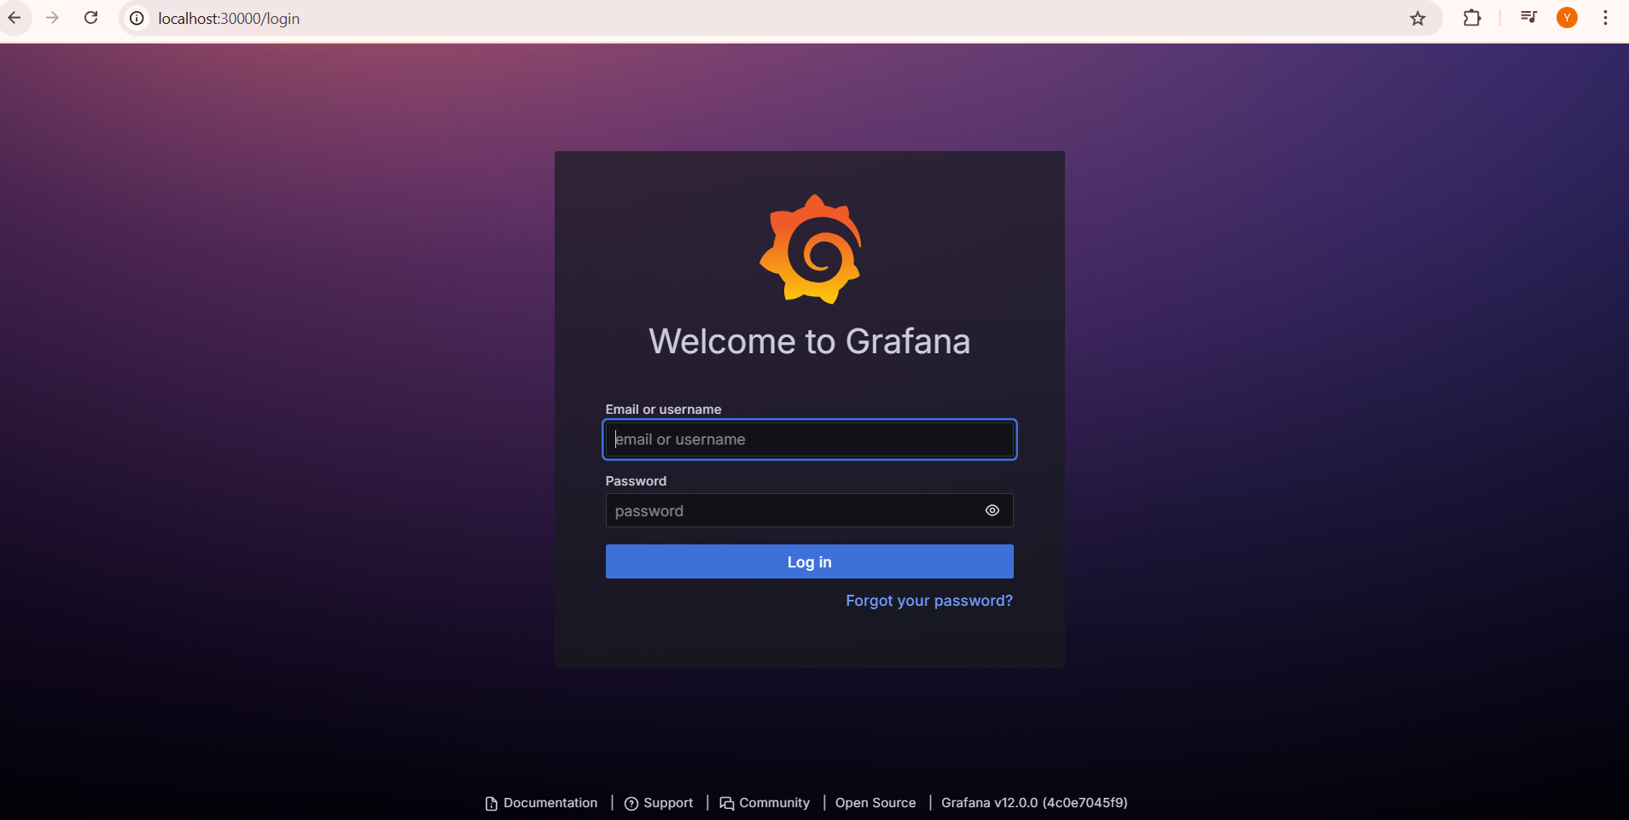

Get the login- password using bewlo command



Decode the it into base64

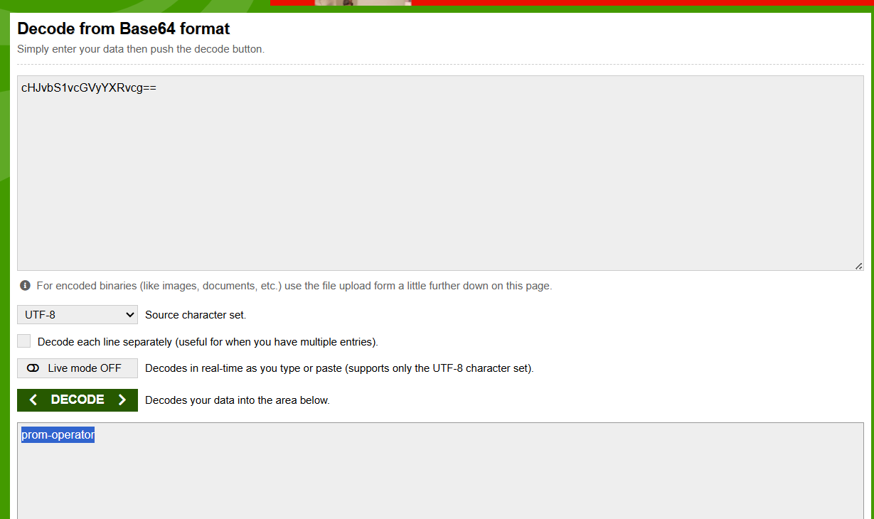

Check out the result

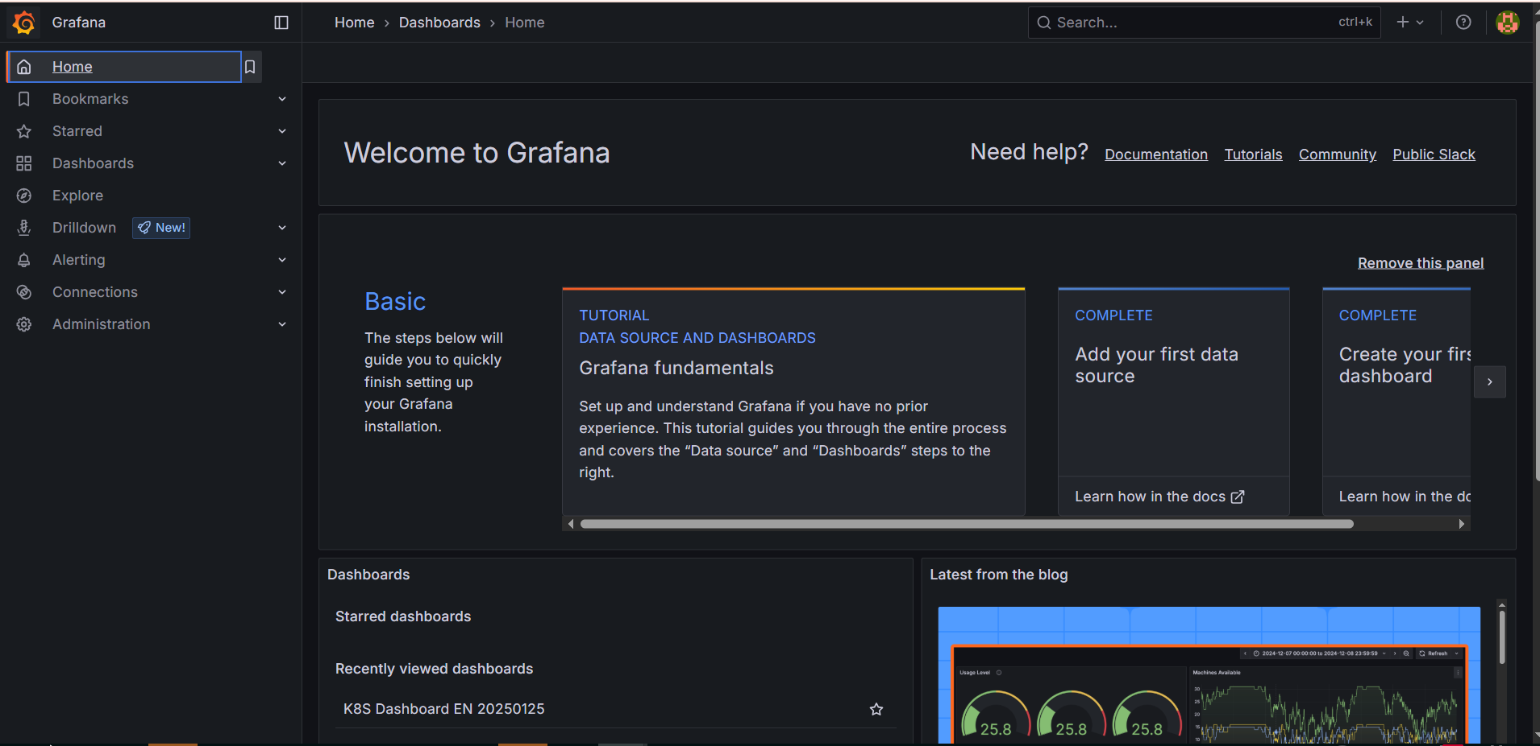

Adding Dashboard

1)CPU Utilization Details (cores) from garfana dashboard official sites

Copying the id

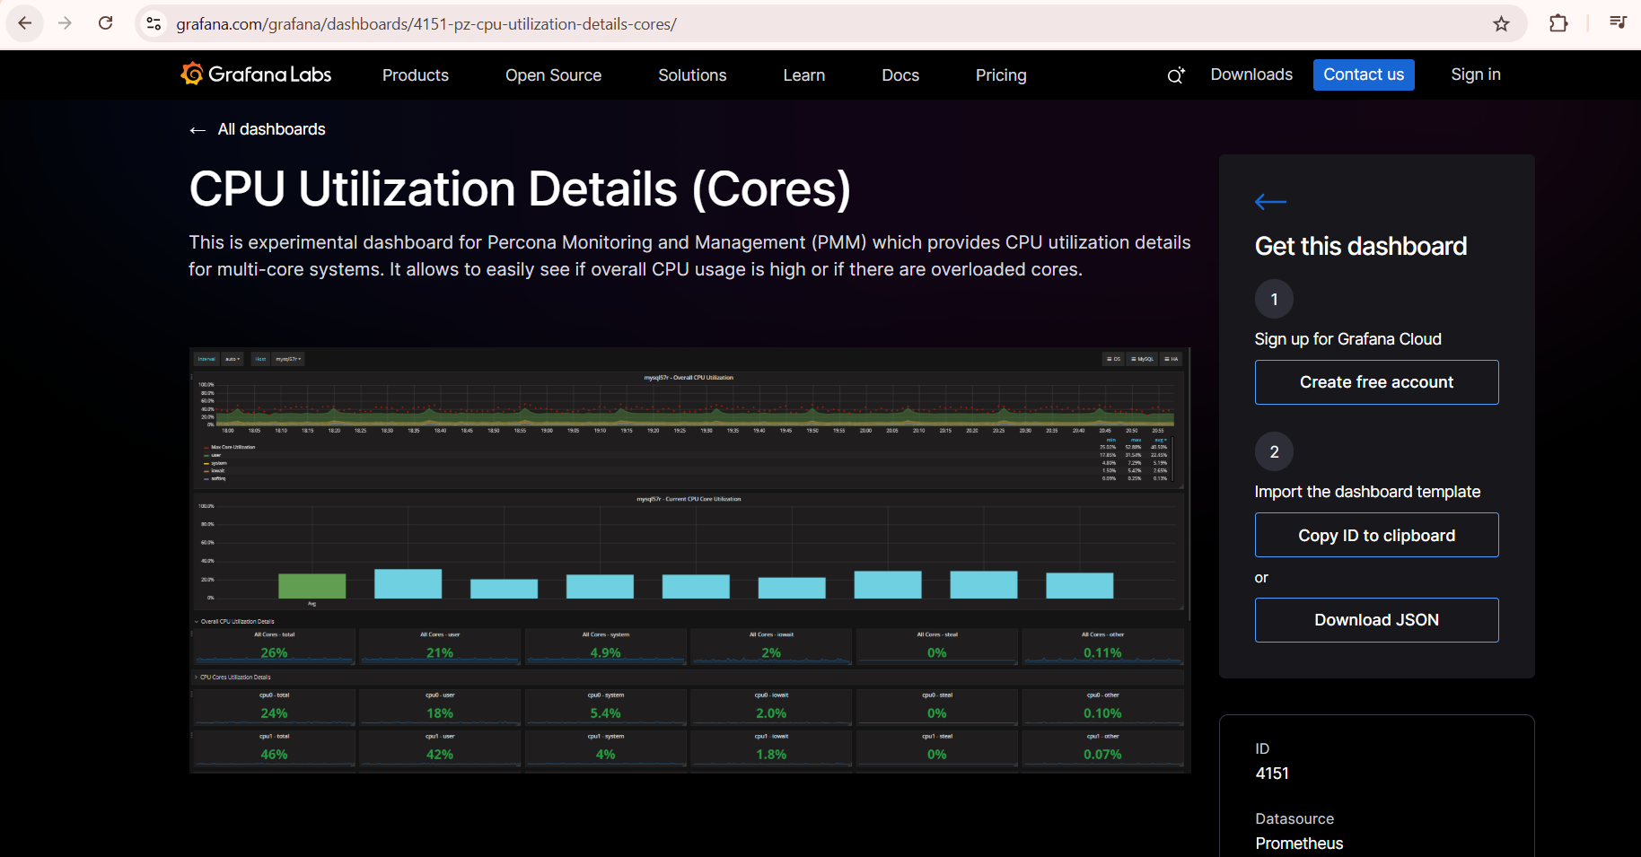

Importing into your dashboard with loading it with same id

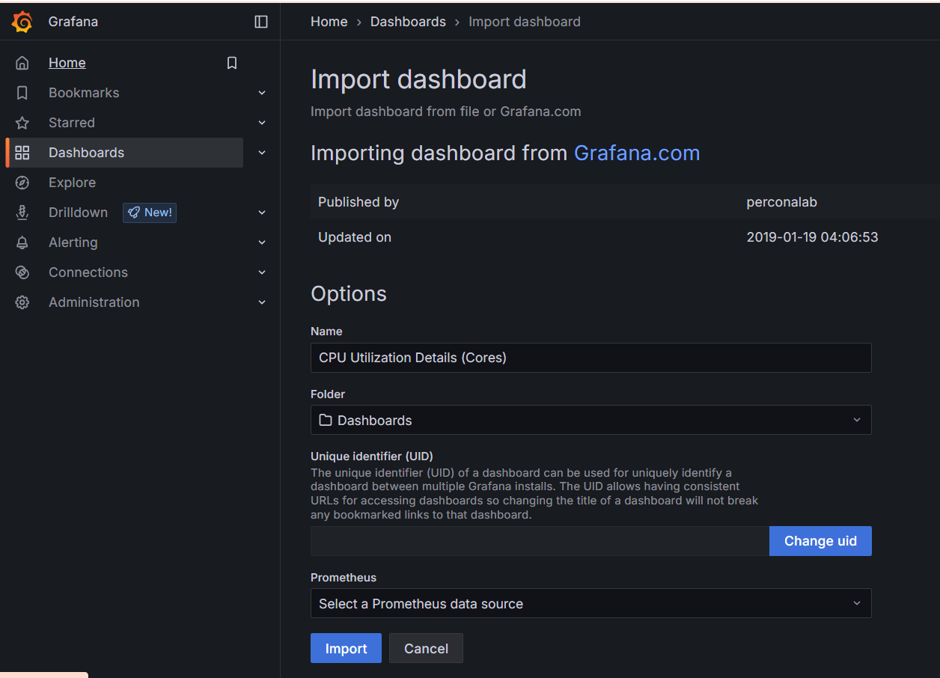

Check out the result below

